Name: VEN THON

ID: e20191250

Group: I3-GIC-C

1). What is Boolean algebra?

* Boolean algebra is the subarea of values of the variables are the truth values true and false usually denoted 1 and 0 respectively.

2). In your opinion, what are differences between “exclusive or” and “equivalence”?

* The difference between exclusive or and equivalence:
* Exclusive or is a logical operation that is true if and only if its arguments differ (one is true, the other is false).
* The equivalence can be established by applying De Morgan's laws twice to the fourth line of the above proof.

So exclusive or is also equivalent to the negation of a logical biconditional, by the rules of material implication (a material conditional is equivalent to the disjunction of the negation of its antecedent and its consequence) and material equivalence.

3). What are differences between Boolean functions and expressions?

* The difference between Boolean expression and function:
* A Boolean expression always produces a Boolean value. A Boolean expression is composed of a combination of the Boolean constants (True or False), Boolean variables and logical connectives.
* A Boolean function is a special kind of mathematical function f: xn→X of degree n, where X={0,1} is a Boolean domain and n is NAME: TOUN DINA GROUP: GIC. C ID: e20191207 a non-negative integer. It describes the way how to derive Boolean output from Boolean inputs.

4). What is dual of a Boolean expression? Give 2 examples of it?

* The dual of a Boolean expression is the expression one obtains by interchanging addition and multiplication and interchanging 0's and 1's.
* Ex: F = (A +B).B + 0
* Dual F = ( A ·C + B) · 1 = A · C + B Ex: G = X ·Y +(w +Z)

Dual G = (X+Y)·(W ·Z) = (X+Y) ·(w +Z)

5). What is logic gate?

* A logic gate is a device that acts a building block for digital circuits.

6). How can we build a circuit that computes the function?

a) xy + x(¬y)?

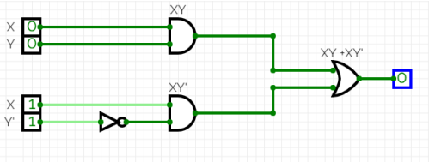

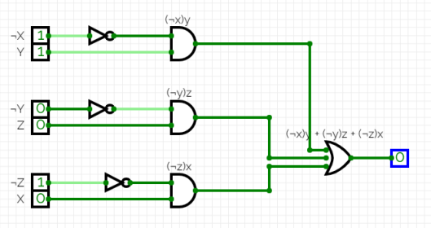b) xy + xz + (¬y)z?

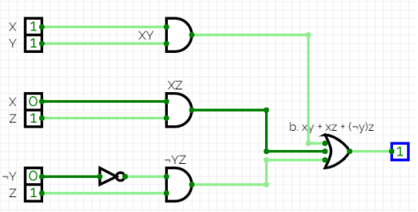c) (¬x)y + (¬y)z + (¬z)x?